Periodic Motion & Simple Harmonic Motion
HyperPhysics

http://hyperphysics.phy-astr.gsu.edu/hbase/shm.html
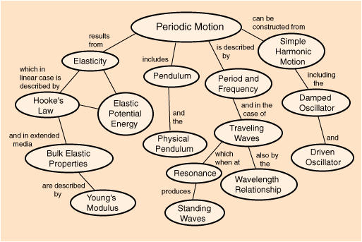
Elasticity
- Elasticity is the property of an object or material which causes it to be restored to its original shape after distortion.
- It is said to be more elastic if it restores itself more precisely to its original configuration.
- A rubber band is easy to stretch, and snaps back to near its original length when released, but it is not as elastic as a piece of piano wire.
- The piano wire is harder to stretch, but would be said to be more elastic than the rubber band because of the precision of its return to its original length. A real piano string can be struck hundreds of times without stretching enough to go noticeably out of tune.
- A spring is an example of an elastic object - when stretched, it exerts a restoring force which tends to bring it back to its original length.
- This restoring force is generally proportional to the amount of stretch, as described by Hooke's Law.
- For wires or columns, the elasticity is generally described in terms of the amount of deformation (strain) resulting from a given stress (Young's modulus). Bulk elastic properties of materials describe the response of the materials to changes in pressure.

Hooke's Law

One of the properties of elasticity is that it takes about twice as much force to stretch a spring twice as far. That linear dependence of displacement upon stretching force is called Hooke's law.

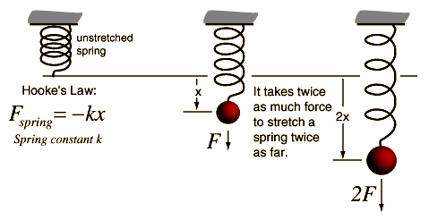

Simple Harmonic Motion
Simple harmonic motion is typified by the motion of a mass on a spring when it is subject to the linear elastic restoring force given by Hooke's Law. The motion is sinusoidal in time and demonstrates a single resonant frequency.
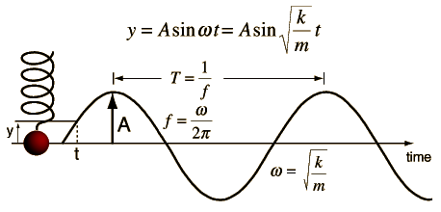

Simple Harmonic Motion Equations
The motion equation for simple harmonic motion contains a complete description of the motion, and other parameters of the motion can be calculated from it.
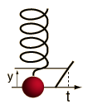 | 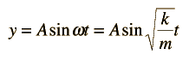  The velocity and acceleration are given by  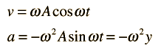  The total energy for an undamped oscillator is the sum of its kinetic energy and potential energy, which is constant at  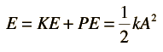

Simple Harmonic Motion Frequency
The frequency of simple harmonic motion like a mass on a spring is determined by the mass m and the stiffness of the spring expressed in terms of a spring constant k (see Hooke's Law):
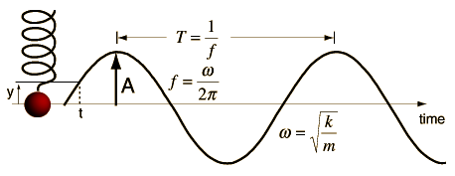
If the period is T = s
then the frequency is f = Hz and the angular frequency = rad/s.
The motion is described by $ω=\sqrt{\frac{k}{m}}$ = Angular Frequency = sqrt (Spring constant / (Mass )
Any of the parameters in the equation can be calculated by clicking on the active word in the relationship above. Default values will be entered for any missing data, but those values may be changed and the calculation repeated.

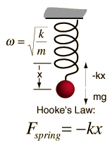
Mass on Spring Resonance
A mass on a spring has a single resonant frequency determined by its spring constant k and the mass m. Using Hooke's law and neglecting damping and the mass of the spring, Newton's second law gives the equation of motion:
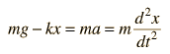
The solution to this differential equation is of the form:
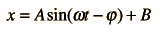
which when substituted into the motion equation gives:
Collecting terms gives B=mg/k, which is just the stretch of the spring by the weight, and the expression for the resonant vibrational frequency:
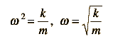
This kind of motion is called simple harmonic motion and the system a simple harmonic oscillator.

Mass on Spring: Motion Sequence
A mass on a spring will trace out a sinusoidal pattern as a function of time, as will any object vibrating in simple harmonic motion. One way to visualize this pattern is to walk in a straight line at constant speed while carriying the vibrating mass. Then the mass will trace out a sinusoidal path in space as well as time.
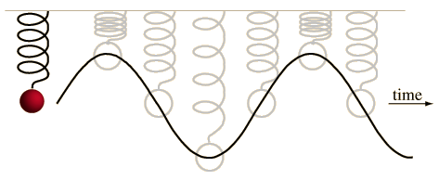

Energy in Mass on Spring
The simple harmonic motion of a mass on a spring is an example of an energy transformation between potential energy and kinetic energy. In the example below, it is assumed that 2 joules of work has been done to set the mass in motion.
